ish¿u ysñlï weúßKs $ All Rights Reserved

St. Peter's College

St. Peter's College

St. Peter's College

புனித பேதுரு கல்லூரி

புனித பேதுரு கல்லூரி

புனித பேதுரு கல்லூரி

புனித பேதுரு கல்லூரி

புனித பேதுரு கல்லூரி

புனித பேதுரு கல்லூரி

புனித பேதுரு கல்லூரி

புனித பேதுரு கல்லூரி

Ydka; mS;r úÿy,

Ydka; mS;r úÿy,

Ydka; mS;r úÿy,

Ydka; mS;r úÿy,

Ydka; mS;r úÿy,

Ydka; mS;r úÿy,

Ydka; mS;r úÿy,

Ydka; mS;r úÿy,

Ydka; mS;r úÿy,

Ydka; mS;r úÿy,

St. Peter's College

St. Peter's College

St. Peter's College

St. Peter's College

St. Peter's College

St. Peter's College

St. Peter's College

St. Peter's College

St. Peter's College

St. Peter's College

புனித பேதுரு கல்லூரி

புனித பேதுரு கல்லூரி

புனித பேதுரு கல்லூரி

புனித பேதுரு கல்லூரி

புனித பேதுரு கல்லூரி

புனித பேதுரு கல்லூரி

புனித பேதுரு கல்லூரி

புனித பேதுரு கல்லூரி

Ydka; mS;r úÿy,

Ydka; mS;r úÿy,

Ydka; mS;r úÿy,

Ydka; mS;r úÿy,

Ydka; mS;r úÿy,

Ydka; mS;r úÿy,

Ydka; mS;r úÿy,

Ydka; mS;r úÿy,

Ydka; mS;r úÿy,

Ydka; mS;r úÿy,

St. Peter's College

St. Peter's College

St. Peter's College

St. Peter's College

St. Peter's College

St. Peter's College

St. Peter's College

34

E

**I,II**

**úoHdj**

**Science**

**meh 02**

**Two Hours**

**08 fY%aKsh – m<uq jdr we.hsu - 2024**

***Grade 08 – First Term Examination - 2024***

Ydka; mS;r úÿy, - fld<U 04

புனித பேதுரு கல்லூரி, கொழும்பு 4

***St. Peter's College - Colombo 04***



Name: ''''''''''''''''''''''''''''''''''''''''''''''''''''''''''''''''''''''''''''''''''''''' Class: '''''''''''''''''''' No: ''''''''''''''''''

**Part - I**

* **Underline the most suitable answer.**

01. An example for a plant species which store food in adventitious roots is,

i. Beet ii. Potato iii. Sweet Potato iv. Banana

02. What is the favourable temperature for the rapid growth of micro-organisms,

i. ii.

iii. iv.

03. To which animal group “Nereis” belongs to,

i. Arthropoda ii. Annelida iii. Mollusca iv. Cnidaria

04. Select the incorrect statement about the arrangement of these particles,

i. Particles are not orderly arranged

ii. Particles are strongly bounded

iii. Much space is left among the particles

iv. This represents the arrangement of the particles in liquids

05. Which element exists as a liquid and a non-metal form?

i. Mercury ii. Chlorine iii. Bromine iv. Sodium

06. Select the incorrect answer.

i. Producing new plants from their plant leaves - Begonia

ii. Absorbing air from the atmosphere - Orchid

iii. Do perennation - Ginger

iv. Bearing photosynthetic stems - Cactus

07. An example for the leaf arrangement given above is,

i. Anona ii. Guava iii. Rukkaththana iv. Kanda

08. Which infectious disease caused to man by a bacterial species,

i. Leishmaniasis ii. Pityriasis

iii. Dengue iv. Tuberculosis

09. Underline the false statement about the group ‘Aves’,

i. They have bilateral symmetrical bodies.

ii. Breath using lungs.

iii. Forelimbs are adapted as wings.

iv. All the above statements are correct.

10. Exists as a white colour powder and can be used as a food additive. Which compound suits with the above description,

i. Sodium Hydroxide ii. Sodium Chloride

iii. Calcium Chloride iv. Copper Sulphate

11. Select the correct statements about plants,

i. Plants are autotrophic

ii. They have chlorophyll pigments

iii. All the animals depend on plants directly or indirectly.

iv. All the above statements are correct.

12. Which micro-organism can be observed through the microscope after keeping a sample of coconut water for few days?

i. Mucor ii. Amoeba iii. Yeast iv. Paramecium

13. Which group of vertebrates shows the metamorphosis and possesses a wet and glandular skin,

i. Amphibia ii. Arthropoda iii. Reptilia iv. Pisces

14. Select the incorrect statement about carbon,

i. Carbon is a metal.

ii. Carbon exists as a solid.

iii. Carbon exists as a greyish black colour powder.

iv. All the above statements are wrong.

15. Examples for the substances which have the properties of elasticity and brittleness,

i. Aluminum and Plastic ii. Rubber and Glass

iii. Clay and Gems iv. Rubber and Aluminum

16. Underline the correct statement of the plant species given above,

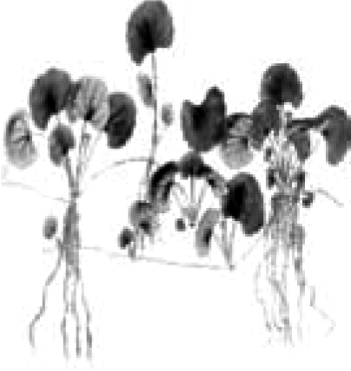

i. It is a plant with an underground stem.

ii. It has still roots.

iii. It is a plant with a propagative stem.

iv. It can be found in coastal area.

17. Select the false statement about food spoilage,

i. Food becomes unfavourable for consumption is known as food spoilage.

ii. The main reason for food spoilage is the growth of micro-organisms on food.

iii. Food spoilage can be considered as a beneficial effect of micro-organisms.

iv. Consuming spoilt food will cause diseases.

18. - Viruses show living features as well as non-living features.

- All the bacterial types cause diseases to man.

- Some fungal varieties are consumed by man.

Which are the correct statements from above,

i. Only ii. Only and b iii. Only and c iv. Only

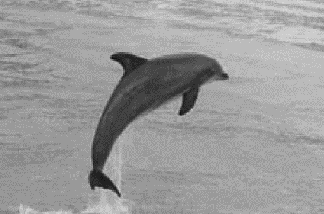

19. Underline the incorrect statement about the animal shown in the figure,

i. It is an aquatic animal.

ii. Gills are used for respiration.

iii. They don’t lay eggs.

iv. Fins are used for locomotion.

20. - Animals with a backbone are known as vertebrates.

- Animals are heterotrophic.

- Animals show different morphological features.

Select the correct statement about animals,

i. Only and ii. Only and

iii. Only and iv. and

**(20240 Marks)**

**Part - II**

* **Question number one is compulsory. Answer another four questions. Total number of questions to be answered is five.**

01. Things in our environment can be divided into two groups such as matter an energy. There is a particulate nature in matter.

i. Define the discontinuous nature or particulate nature of matter. **(01)**

__________________________________________________________________________________________________________________________________________

ii. Name the three physical state of matter and explain the reason. **(03)**

_______________________________________________________________________________________________________________________________________________________________________________________________________________

iii. Name two physical properties that can be used to examine the purity of a substance. **(02)**

__________________________________________________________________________________________________________________________________________

iv. Based on the nature of the pure substances, they can be classified into two groups such as elements and compounds define ‘compounds’. **(02)**

_______________________________________________________________________________________________________________________________________________________________________________________________________________

v. Write the elements that are contained in the compounds given below. **(02)**

). Carbon dioxide

_______________________________________________________________

). Water

_______________________________________________________________

vi. Give the scientific explanations for the following.

). Solids have a definite shape. But liquids and gases have no definite shape. **(01)**

______________________________________________________________________________________________________________________________

). Solids and liquids cannot be compressed easily. But gases can be compressed easily. **(01)**

______________________________________________________________________________________________________________________________

vii. Complete the table.

|  |  |  |
| --- | --- | --- |
| **Instance of application** | **Substance** | **Physical property of matter** |
| Making tyres and tubes | ____________________ | ____________________ |
| Making jewellery | ____________________ | ____________________ |
| Making tools | ____________________ | ____________________ |
| Making electrical wires | ____________________ | ____________________ |

**(16 Marks)**

02. Leaves of a plant are considered as the most significant part of a plant.

i. Explain the leaf arrangement of a plant. **(01)** __________________________________________________________________________________________________________________________________________

ii. Write the importance of having different leaf arrangements in plants. **(01)**

__________________________________________________________________________________________________________________________________________

iii. Give an example for each leaf arrangement given below.

). Leaves are attached in a spiral manner around the stem. **(01)**

_______________________________________________________________

). Three or more leaves attach at each node on the stem in a whirl. **(01)**

_______________________________________________________________

iv. Write the specific function of the parts of plants given below.

). Underground stem **(01)**

_______________________________________________________________

). Photosynthetic stem **(01)**

_______________________________________________________________

). Aerial roots **(01)**

_______________________________________________________________

). Climbing roots **(01)**

_______________________________________________________________

v. Define ‘transpiration’ **(01)**

__________________________________________________________________________________________________________________________________________

vi. What is the importance of this process transpiration? **(01)**

_____________________________________________________________________

vii. Write two adaptations of arid plants to minimize transpiration. **(01)**

__________________________________________________________________________________________________________________________________________

**(11 Marks)**

03. Fill in the blanks and complete the paragraph about the animal diversity.

Animal can be classified into two main groups such as vertebrates and ________________.

Having two forms such as polyps and Medusa is a feature of ________________ and they have ________________ symmetrical bodies.

Having externally segmented bodies and jointed appendages are features of ________________. ________________ are known as segmented worms and their bodies are divided into segments.

________________ are the respiratory organs of group pisces and ________________ are the respiratory organs of Aves.

Possess a dry skin with scales is a feature of ________________ and they have ________________ symmetrical bodies. Possessing an external ear with ear lobe are a feature of ________________ and they have ________________ in their skin.

**(11 Marks)**

04. Living organisms can be divided into three main groups such as plants, animals and micro-organisms.

i. Define ‘Micro-organism’ **(01)** __________________________________________________________________________________________________________________________________________

ii. Identify the micro-organisms given below and name them. **(03)**

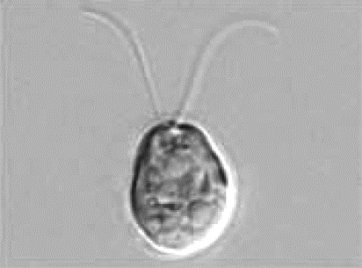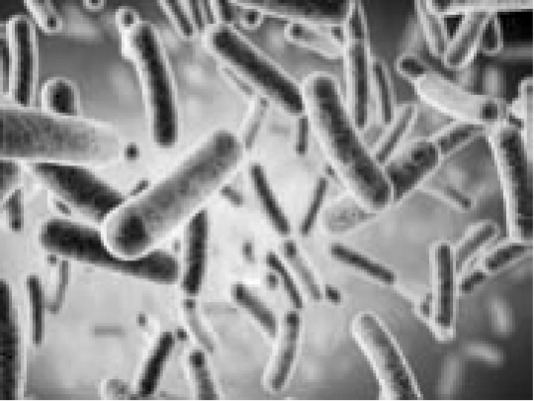

). __________________ ). __________________

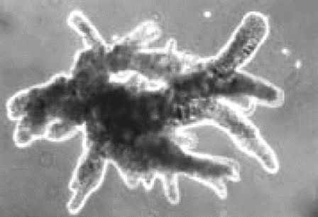

). ____________________

iii. What are the two main factors needed for the growth of micro-organisms **(01)** __________________________________________________________________________________________________________________________________________

iv. Answer the questions using the pictures given below.

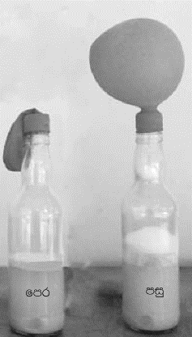

Write two observations that can be taken after keeping the solution with sugar and yeast for sometime. **(02)**

__________________________________________________________________________________________________________________________________________

v. Write two beneficial effects of micro-organisms. **(02)** __________________________________________________________________________________________________________________________________________

vi. Write two harmful effects of micro-organisms **(02)** __________________________________________________________________________________________________________________________________________

**(11 Marks)**

05. Mark these statements () or ().

i. All the animals can locomote ( )

ii. Mercury is a metal that exists as a liquid ( )

iii. Sulphur is a poor conductor of heat and carbon is a good conductor

of electricity ( )

iv. Arthropoda is the group to which the highest number of animals belongs ( )

v. Curry leaves and banana trees show the same vegetative propergation

method to produce new plants. ( )

vi. Paramecium and mucor are classified under protozoans ( )

vii. Streamlined body shape of pisces and Aves helps in their locomotion ( )

viii. Microbial activity on food that’s high in fats leads to rancidity. ( )

ix. The specific function of the aerial roots of a plant is to absorb moisture

from the atmosphere ( )

x. Polio and malaria are infectious diseases caused to man by virus ( )

xi. We get the same value for the density of distilled water and marine water ( )

**(11 Marks)**

06. Answer the questions using the picture given below.

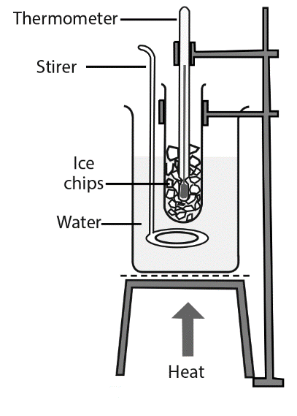

i. What is the purpose of designing an apparatus which given above. **(02)** __________________________________________________________________________________________________________________________________________

ii. Why we use the stirrer for the above experiment. **(01)** __________________________________________________________________________________________________________________________________________

iii. What kind of observation that can be detected after supplying the heat. **(02)** __________________________________________________________________________________________________________________________________________

iv. What is the specific temperature at which this change in state occurs during the experiment? **(02)**

_____________________________________________________________________

v. What is the final conclusion of this experiment? **(02)**

__________________________________________________________________________________________________________________________________________

vi. After analyzing the observations and conclusions what can you say about the water sample? **(02)**

__________________________________________________________________________________________________________________________________________

**(11 Marks)**